Logan Annual Town Meeting
Record of Proceedings
March 12, 2019
Logan Town Clerk Craig LeBlanc called the meeting to order at 7:00 pm.
Present: Lisa Bryan, Lois Fultz, Craig LeBlanc, Dave Tevis and Jim Berg.
- Lisa Bryan motioned to nominate Lois Fultz as moderator for the Annual Meeting, second by Dave Tevis. Motion passed with all in favor.
- Lisa Bryan motioned to approve the minutes from the Logan Annual Town meeting on March 13, 2018, second by Dave Tevis. Motion passed with all in favor.
- 2018 Year End Report: General $61,671.96
Road and Bridge $41,949.86
Fire $-391.92
Gas Tax $0.00
Cemetery $22,573.30
End Balance $125,803.20
- February 2018 Board of Audit: A random check of receipts and disbursements was completed. The board recommended increasing the Fire Fund distribution to 11% to cover cost increases and reducing the General Fund distribution to 24%.

2020 Levy
2019 Levy and Fund Distribution Proposed 2020 Levy and Fund Distribution
General Fund $17,500 25.0% General Fund $16,800 24.0%
Road & Bridge Fund $39,200 56.0% Road & Bridge Fund $39,200 56.0%
Fire Fund $7,000 10.0% Fire Fund $7,700 11.0%
Cemetery $6,300 9.0% Cemetery $ 6,300 9.0%
Total $70,000 100.0% Total $70,000 100.00%

- The total taxable valuation of Logan Township for the assessment year 2018 and tax year payable 2019 is $27,029,410 and the net tax capacity is $238,482.

- Dave Tevis motioned to accept the proposed 2020 levy, second by Craig LeBlanc. Motion passed with all in favor.

Logan Annual Town Meeting
Record of Proceedings
March 12, 2019
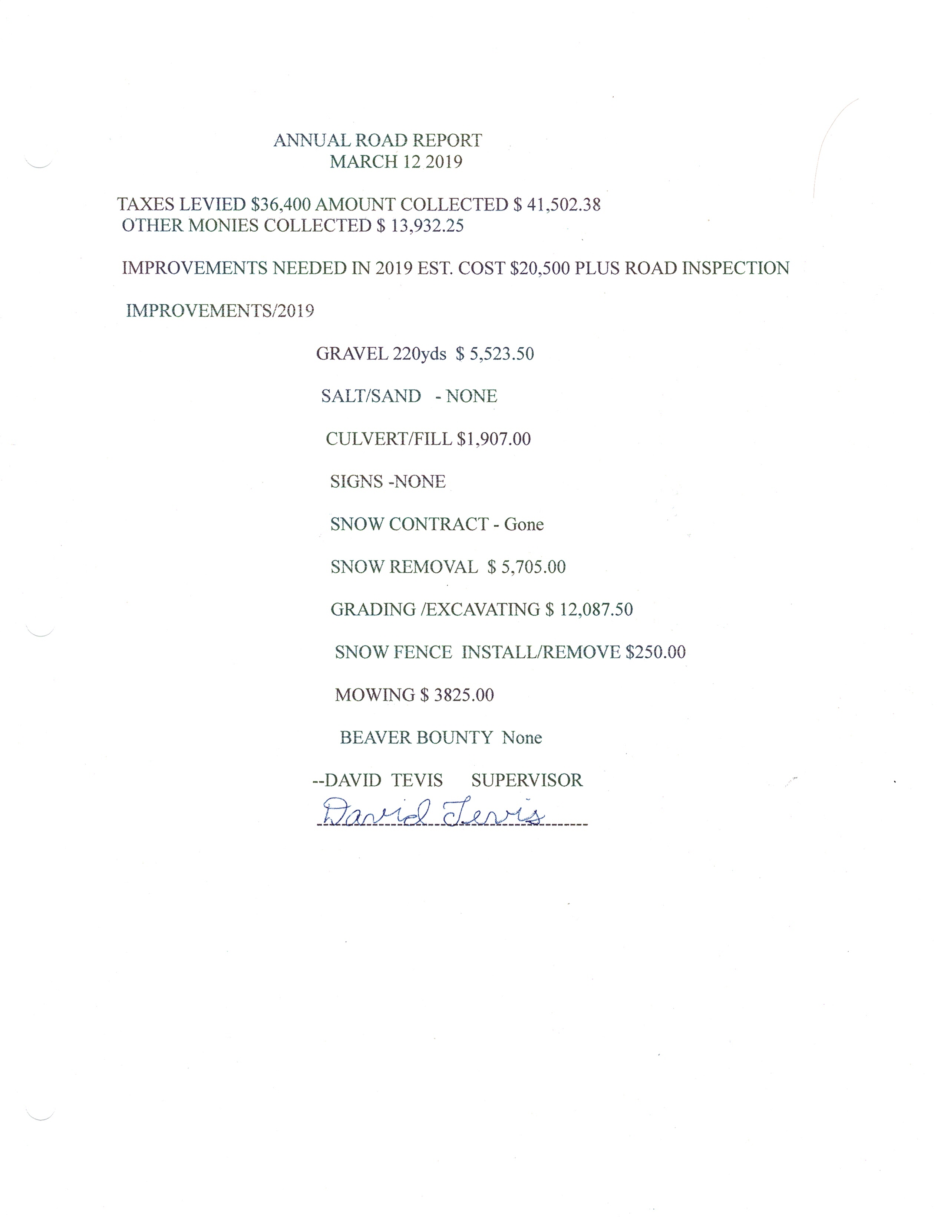
- Logan Township is currently receiving Highway User Tax funds for the extension of 290th Place
while transfer of ownership from Aitkin County is pending.

CEMETERY REPORT:
- There were 4 burials from March 2018 to March 2019.
- The chapel needs a safe removed, windows replaced and other repairs. A fund raiser could be held to pay for some of the cost of repairs.
- Lisa Bryan recommended planting pine trees to replace those that have been removed. She also mentioned that the chapel has a safe that should be removed and needs windows and other repairs.

DONATION AND CONTRACT FOR SERVICE REQUESTS:
- Angels Elderly Live-in Services: Letter requesting a donation.
- Crisis Line and Referral Service: Letter requesting a contract for services.
- First Call For Help: Letter requesting a contract for services.
- Support Within Reach
Logan Annual Town Meeting
Record of Proceedings
March 12, 2019

OTHER BUSINESS:
- The Aitkin County Board of Appeal and Equalization Open Meetings for Logan Township and County Board of Equalization will be held at the Aitkin County Assessor’s Office, 209 2nd Street NW Room 211, Aitkin MN 56431 at the following times:
Open Book Meeting 5/2/2019 9:00 am to 7:00 pm
County Board of Equalization 6/25/2019 By appointment

MOTION TO ADJOURN OR CONTINUE:
- Dave Tevis motioned to hold the 2020 Annual Meeting on March 10, 2020 at 7:00 pm at the Palisade Community Center, or in the case of inclement weather on March 17, 2020 at 7:00 pm at the Palisade Community Center, second by Lisa Bryan. Motion carried with all in favor.

- Dave Tevis motioned to adjourn the meeting at 7:30 pm, second by Lisa Bryan. Motion passed with all in favor.

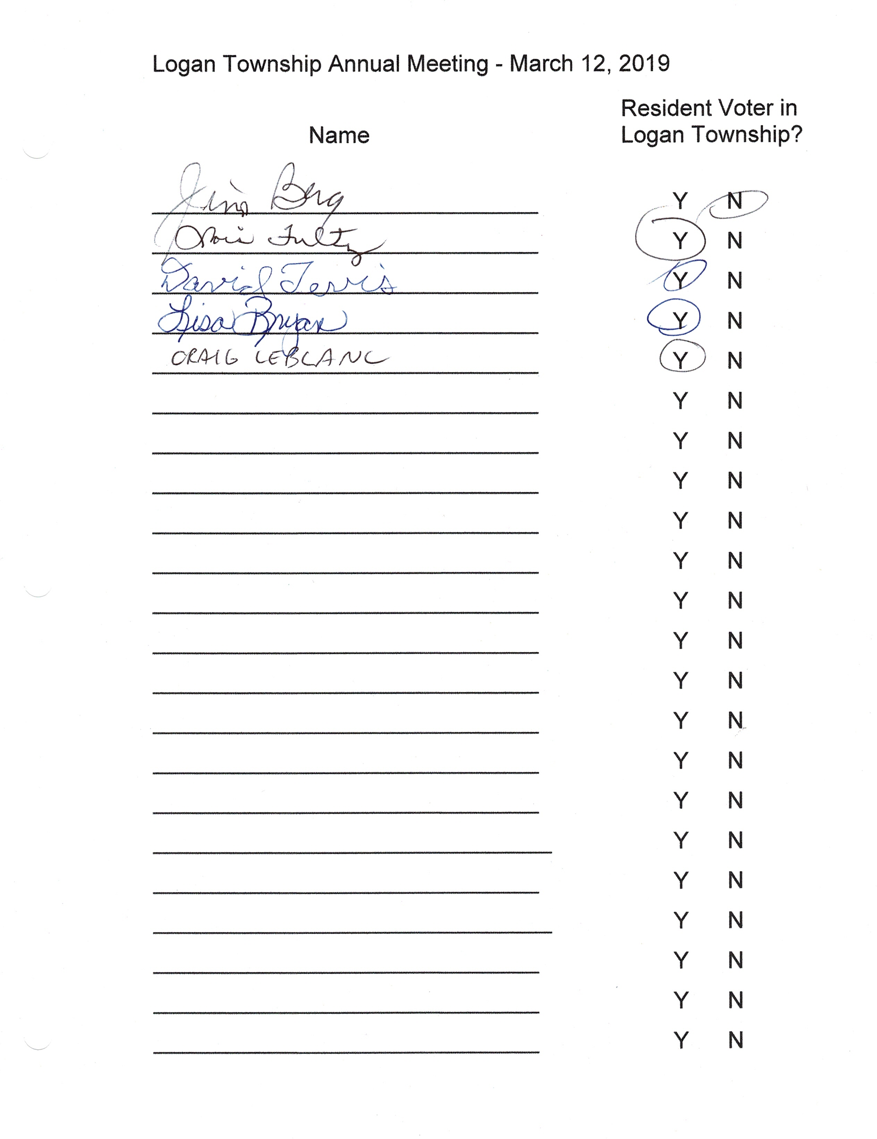

_______________________________ 4-10-2019
Moderator - Lois Fultz Date

