Logan Annual Town Meeting Record of Proceedings
March 9, 2021
Logan Town Clerk Craig LeBlanc called the meeting to order at 7:00 pm.
Present: Lisa Bryan, Lois Fultz, Craig LeBlanc, Lynn Mizner, Dave Sims and Chris Gamer.
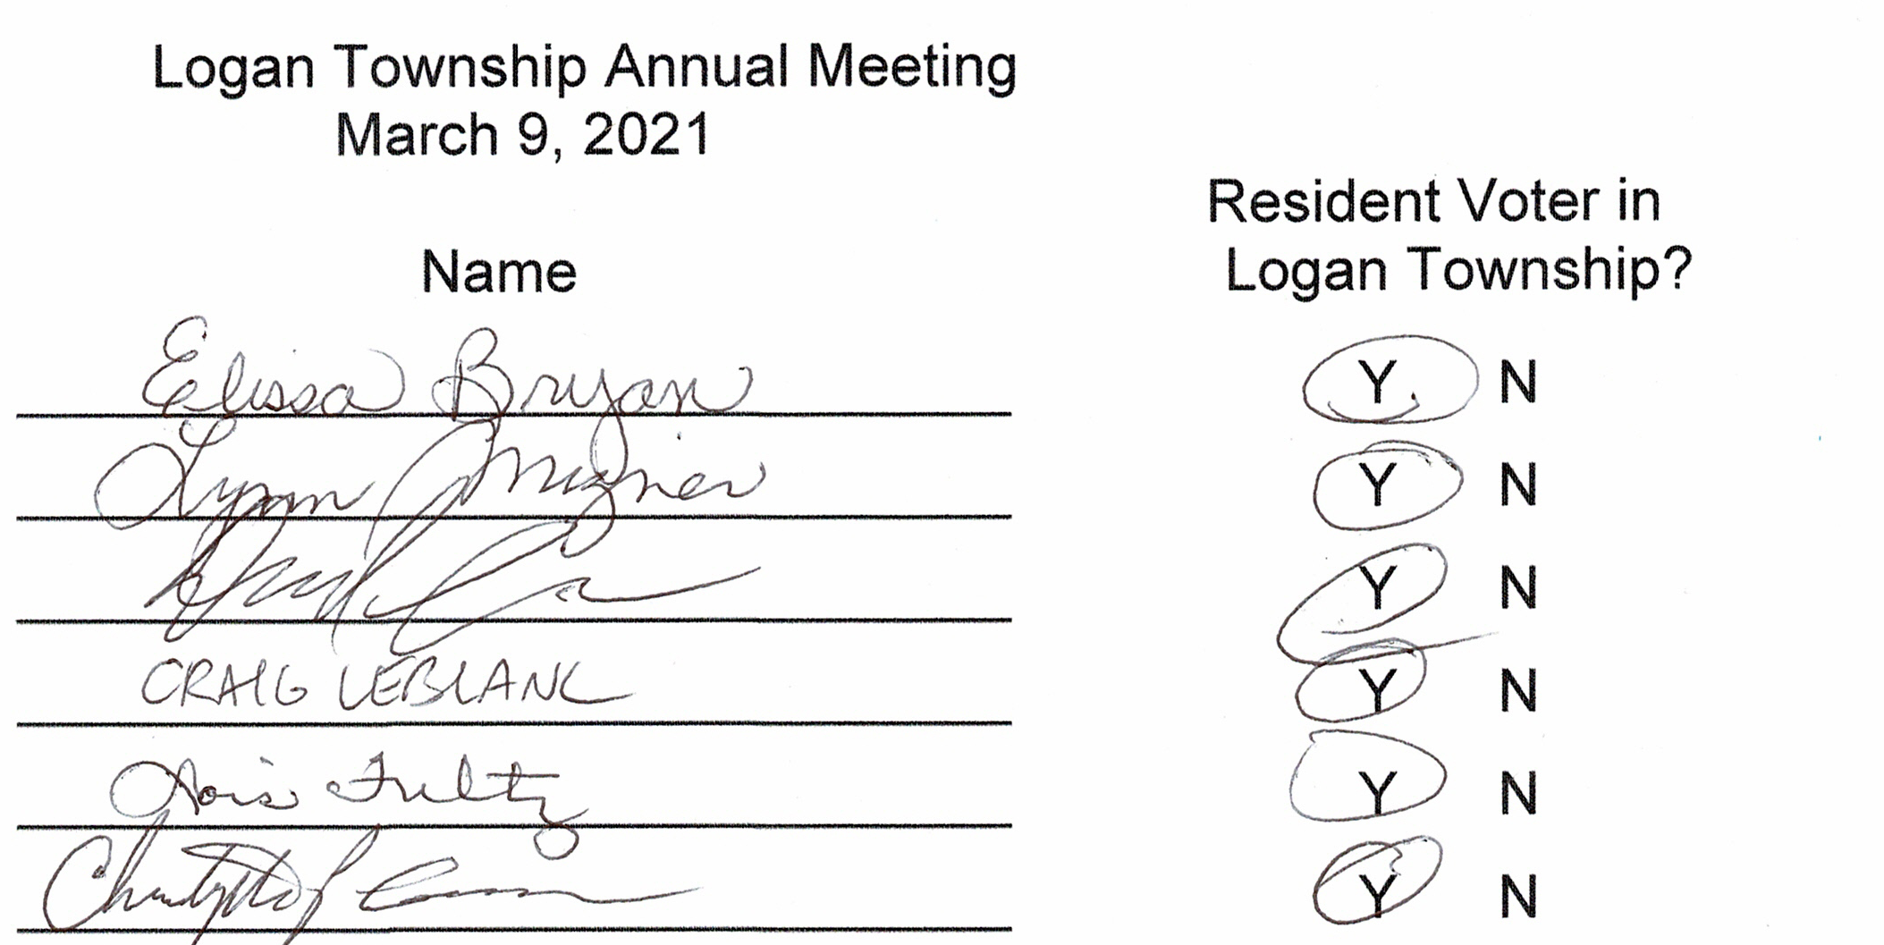
- Lynn Mizner motioned to nominate Chris Gamer as moderator for the Annual Meeting, second by Lisa Bryan.
Motion passed with all in favor.
- Dave Sims motioned to approve the minutes from the 2020 Logan Annual Town Meeting, second by Lisa Bryan. Motion passed with all in favor.
- Treasurer’s 2020 Year End Report: General $57,122.25
Road and Bridge $64,755.04
Fire $9,062.42
Gas Tax $0.00
Cemetery $29,072.26
End Balance $160,011.97
- February 2021 Board of Audit: A random check of receipts and disbursements was completed with th clerk’s books matching the treasurer’s books. The board recommended leaving the total levy at $75,000, increasing the Road & Bridge and Fire Funds to cover projected cost increases and decreasing the General and Cemetery Funds as follows:

2022 Levy
2021 Levy and Fund Distribution Proposed 2022 Levy and Fund Distribution
General Fund $16,500 22.0% General Fund $15,000 20.0%
Road & Bridge Fund $44,250 59.0% Road & Bridge Fund $45,750 61.0%
Fire Fund $7,500 10.0% Fire Fund $8,250 11.0%
Cemetery $6,750 9.0% Cemetery $6,000 8.0%
Total $75,000 100.0% Total $75,000 100.00%

The total taxable market valuation of Logan Township for the assessment year 2020
and tax year payable 2021 is $29,993,988 and the net tax capacity is $268,190.

- Lois Fultz motioned to accept the proposed 2022 levy, second by Craig LeBlanc. Motion passed with all in favor.
Logan Annual Town Meeting Record of Proceedings
March 9, 2021
Annual Road Report:
- Lynn Mizner motioned to accept the 2021 Annual Road Report, second by Lisa Bryan. Motion passed, all in favor.
Logan Annual Town Meeting Record of Proceedings
March 9, 2021

CEMETERY REPORT:
- Seven graves sold.
- Three burials.
- Lois Fultz donated lumber for repair of the chapel porch.
- Expenses for 2020 were $5951

DONATION AND CONTRACT FOR SERVICE REQUESTS:
- Aitkin County Search and Rescue Volunteers: Request for donation.
- Angels Elderly Live-in Services: Request for donation.
- Crisis Line and Referral Service: Requesting contract for services.
- First Call 211: Requesting contract for services.
- Minnesota Food Share: Request for donation.
- Seven County Senior Federation: Requesting contract for services.
- Support Within Reach – Sexual Violence Resource Center: Requesting contract for services.

OTHER BUSINESS:
- The 2003 Annexation of Logan Township property was partly based on the City of Palisade’s plan to provide
water and septic service to the annexed properties. Under current law, there is no deadline for these services
to be provided and detachment can only be initiated by the city or the affected property owners. MAT is currently
promoting legislation to give towns and cities equal power in annexations and to make annexations a binding
agreement between cities and towns with time limits on completion of services planned by the city. MAT is also
promoting legislation that allows townships to initiate detachments and gives property owners a vote on whether or not they will be annexed.

- Craig LeBlanc mentioned contacting Logan Township residents by mail for a survey on town issues, contact information and other information about the town. This mailing was planned a few years ago but was never completed.

MOTION TO ADJOURN OR CONTINUE:
- Lynn Mizner motioned to hold the 2022 Annual Meeting on March 8, 2022 at 7:00 pm at the Palisade Community Center, second by Lisa Bryan. Motion passed with all in favor.

- Lois Fultz motioned to adjourn the meeting at 7:39 pm, second by Lynn Mizner. Motion passed with all in favor.

_____________________________________________ _________________
Moderator - Chris Gamer Date

