Logan Annual Town Meeting Record of Proceedings
March 8, 2022
Logan Town Clerk Craig LeBlanc called the meeting to order at 7:10 pm.
Present: David Sims, Elissa Bryan, Tammy Wickstrom, Lois Fultz, Craig LeBlanc and Lynn Mizner.
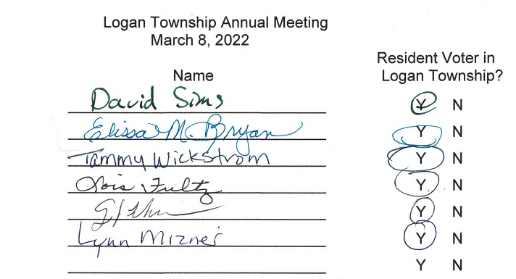
- Lisa Bryan motioned to nominate Tammy Wickstrom as moderator for the Annual Meeting, second by Lois Fultz. Motion passed with all in favor.
- Lisa Bryan motioned to approve the minutes from the 2021 Logan Annual Town Meeting, second by David Sims. Motion passed with all in favor.
- Treasurer’s 2021 Year End Report: General 57,609.79
Road and Bridge 72,363.72
Federal - ARPA 9671.48
Fire 10,125.00
Gas Tax 0.00
Cemetery 35,492.00
End Balance 185,261.99
- February 2022 Board of Audit: A random check of receipts and disbursements was completed with the clerk’s books matching the treasurer’s books. The board recommended increasing the total levy 10% to $82,500 for increased costs and road improvements:
2023 Levy
2022 Levy and Fund Distribution Proposed 2023 Levy and Fund Distribution
General Fund $15,000 20.0% General Fund $16,500 20.0% Road & Bridge Fund $45,750 61.0% Road & Bridge Fund $50,325 61.0%
Fire Fund $8,250 11.0% Fire Fund $9,075 11.0%
Cemetery $6,000 8.0% Cemetery $6,600 8.0%
Total $75,000 100.0% Total $82,500 100.00%
The total taxable market valuation of Logan Township for the assessment year 2021
and tax year payable 2022 is $30,126,265 and the net tax capacity is $269,095.
- David Sims motioned to accept the proposed 2023 levy, second by Lynn Mizner. Motion passed, all in favor.

Logan Annual Town Meeting Record of Proceedings
March 8, 2022
Annual Road Report:

Logan Annual Town Meeting Record of Proceedings
March 8, 2022

ROAD RECOMMENDATIONS:
Tammy Wickstrom mentioned that the roads have not received enough gravel for several years. The current plan is to put 3” of gravel on 2 miles of township road a year and to repair the problem areas as they occur.
The need for brushing was mentioned, with brushing on most township roads recommended on the last two road reports but not completed. Problem areas at the intersection of 290th Place/291st Place and the sharp turns on 291st Place will be brushed before other areas.

CEMETERY REPORT:
- 18 graves sold.
- 9 burials.
- Expenses for 2021 were $7090.64

DONATION AND CONTRACT FOR SERVICE REQUESTS:
- Aitkin County Search and Rescue Volunteers: Request for donation.
- Angels Elderly Live-in Services: Request for donation.
- Crisis Line and Referral Service: Request for donation and contract for services.
- First Call 211: Request for donation and contract for services.
- Jaques Art Center – Request for donation.
- Minnesota Food Share: Request for donation.
- Seven County Senior Federation: Request for donation and contract for services.
- Support Within Reach – Sexual Violence Resource Center: Requesting contract for services.

OTHER BUSINESS:

MOTION TO ADJOURN OR CONTINUE:
- Lisa Bryan motioned to hold the 2023 Annual Meeting on March 14th, 2023 at 7:00 pm at the Palisade Community Center, second by Craig LeBlanc. Motion passed with all in favor.

- David Sims motioned to adjourn the meeting at 7:30 pm, second by Lynn Mizner. Motion passed with all in favor.

