Logan Annual Town Meeting Record of Proceedings
March 14, 2023
Logan Town Clerk Craig LeBlanc called the meeting to order at 7:09 pm.
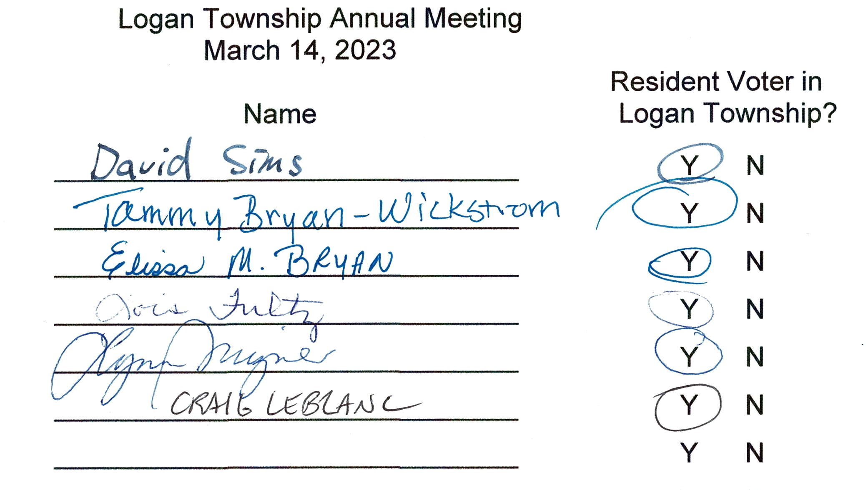
- Lisa Bryan motioned to nominate Tammy Wickstrom as moderator for the Annual Meeting, second by Lois Fultz. Motion passed with all in favor.
- David Sims motioned to approve the minutes from the 2022 Logan Annual Town Meeting with a correction to the meeting date, second by Lisa Bryan. Motion passed with all in favor.
Treasurer’s 2022 Year End Report: General $55,990.58
Road and Bridge $98,571.85
Federal - ARPA $0.00
Fire $11,659.25
Gas Tax $0.00
Cemetery $39,095.11
End Balance $205,316.79
February 2022 Board of Audit: A random check of receipts and disbursements was completed with the clerk’s books matching the treasurer’s books. The board recommended increasing the total levy 3% to $85,000 for increased costs and road improvements.
2024 Levy
2023 Levy / Fund Distribution Proposed 2024 Levy / Fund Distribution
General Fund $16,500 20.0% General Fund $17,000 20.0%
Road & Bridge Fund $50,325 61.0% Road & Bridge Fund $51,850 61.0%
Fire Fund $9,075 11.0% Fire Fund $9,350 11.0%
Cemetery Fund $6,600 8.0% Cemetery Fund $6,800 8.0%
Total $82,500 100.0% Total $85,000 100.0%
Logan Township 2023 taxable market value is $42,065,965 and the net tax capacity is $376,861

Tammy Wickstrom mentioned that all of the money levied for roads should be used each year. She also agreed with recent pay increases, noting that meeting pay and salaries have not changed in over 10 years. She also suggested that the board should replace computers that are outdated.

- Lois Fultz motioned to accept the proposed 2024 levy, second by Lynn Mizner. Motion passed, all in favor.
Logan Annual Town Meeting Record of Proceedings
March 14, 2023
Logan Township 2023 Annual Meeting Road Report
2022 Receipts, Expenses and Road Maintenance/Improvements
 |  |  |  | Road | Grading | Gravel | Brushing
 | 2022 Levy | $45,750.00 |  | 280th Avenue | 7.5
 | Receipts |  |  | 285th Avenue | 10.0
 | Property Tax / Credits | $48,690.69 |  | 290th Place N (N/S) | 8.0 |  | 1.0
 | Town Aid | $1,183.40 |  | 290th Place N (E/W) | 8.5
 | Interest and Refunds | $19.71 |  | 290th Place (South) | 7.0
 | Gas Tax | $17,327.32 |  | 291st Place
 | ARPA | $9,671.47 |  | 310th Avenue
 | Total Receipts | $76,892.59 |  | 312th Place | 4.5
 |  |  |  | 320th Place North | 1.0
 | Expenses |  |  | 320th Place South | 4.0 | 440.0
 | Gravel and Rock | $27,284.00 |  | 330th Avenue | 18.5 |  | 1.0
 | Snow Removal | $10,600.00 |  | 334th Place | 30.5
 | Grading / Excavating | $19,495.00 |  | 340th Place North | 1.0
 | Excavating | $520.00 |  | 340th Place South | 44.0
 | Snow Fence | $329.97 |  | 460th Lane
 | Mowing / Brushing | $1,750.00 |  | 470th Street (East) | 6.5
 | Education | $129.99 |  | 470th Street (West) | 6.0 |  | 1.0
 | Road Inspection | $246.98 |  | 489th Street | 1.0
 | Total Expenses | $60,355.94 |  | 490th Lane | 0.5
 |  |  |  | 495th Lane | 4.0
 | Culvert on 509th Lane was repaired. |  |  | 499th Lane | 15.0 | 660.0
 |  |  |  | 509th Lane | 24.0 | 20.0
 |  |  |  |  | 157.5 | 1,164 | 3.0
 |  |  |  |  | hours | yards | hours
 | Improvement Needed for 2022 – Bold Indicates High Priority Items
 | 280th Avenue | Brushing |  |  | 334th Place (South) |  | Brushing
 | 285th Avenue | Brushing |  |  | 340th Place (North) |  | Gravel - North End
 | 285th Place |  |  |  | 340th Place (South) |  | Gravel
 | 290th Place N (N/S) |  |  |  | 460th Lane
 | 290th Place N (E/W) | Turnaround | Intersection |  | 470th Street (East) |  | Brushing
 | 290th Place (South) | Brushing |  |  | 470th Street (West) |  | Flooding - East Curve
 | 291st Place | Children Playing/Curve Signs |  |  |  |  | Gravel
 | 310th Avenue | Brushing |  |  | 485th Street |  | Brushing
 | 312th Place | Brushing |  |  | 489th Street |  | Brushing
 | 320th Place (North) | Gravel |  |  | 490th Lane |  | Brushing Gravel
 | 320th Place (South) | Branches |  |  | 495th Lane |  | Street Sign Turnaround
 | 330th Avenue |  |  |  | 499th Lane
 | 334th Place (North) | Brushing | Rebuild 100' |  | 509th Lane |  | Gravel
 | 334th Place (North) | Culverts |  |  | Minimum Maintenance

Logan Annual Town Meeting Record of Proceedings
March 14, 2023
ROAD RECOMMENDATIONS:
- Wickstrom culvert at the end of 290th Place: Is this a driveway culvert or a road culvert?
- Tammy Wickstrom recommended repairing 1 to 2 roads a year for a total of 5 miles a year until all roads are repaired.
- Snow from the driveway at the Thompson property (parcel 1-0-018601 at the junction of 290th Place
and 291st Place) is being pushed across the road, leaving that part of the road rough and uneven.

CEMETERY REPORT:
- 5 graves sold.
- 6 burials with 6 pending.
- Expenses for 2022 were $4,650 for mowing and $200 for other upkeep.
- Software for grave location and cemetery records was mentioned. Those present agreed it was a good idea that would improve access for visitors and documentation for the township.

DONATION AND CONTRACT FOR SERVICE REQUESTS:
No donations were recommended.
- Aitkin Community Food Shelf: Request for donation.
- Aitkin County Search and Rescue Volunteers: Request for donation.
- Angels Elderly Live-in Services: Request for donation.
- Crisis Line and Referral Service: Request for donation and contract for services.
- First Call 211: Request for donation and contract for services.
- Jaques Art Center – Request for donation.
- Minnesota Food Share: Request for donation.
- Seven County Senior Federation: Request for donation and contract for services.
- Support Within Reach – Sexual Violence Resource Center: Requesting contract for services.

OTHER BUSINESS:
- Board of Appeal and Equalization: April 4 - 9:00 am to 7:00 pm - Aitkin County Boardroom.

MOTION TO ADJOURN OR CONTINUE:
- Lisa Bryan motioned to hold the 2024 Annual Meeting on March 12th, 2024 at 7:00 pm at the Palisade Community Center, second by Lois Fultz. Motion passed with all in favor.

- Lois Fultz motioned to adjourn the meeting at 8:00 pm, second by Lisa Bryan. Motion passed with all in favor.

_____________________________________________ _________________
Moderator - Tammy Wickstrom Date

