Logan Town Board Meeting Minutes
February 13, 2024
On February 13th, 2024 the Logan Town Board held its monthly meeting at the Palisade Community Center. Chair Dave Sims called the meeting to order at 7:02 pm.
Present: Chair Dave Sims, Supervisor Elissa Bryan, Supervisor Lynn Mizner,
Treasurer Michelle Pieterse, Clerk Craig LeBlanc and Rod Kern.
- Lisa Bryan motioned to approve the January 2024 Logan Town Board Meeting minutes, second by Lynn Mizner. Motion passed, all in favor.
- Lisa Bryan motioned to table the approval of the Treasurer’s Financial Statement pending review of the current bank statements, second by Lynn Mizner. Motion passed, all in favor.
- David Sims motioned to make the 1st of the month the cutoff for the monthly financial report, second by Lisa Bryan. Motion passed, all in favor.
- The Clerk’s books do not balance with the Treasurer’s books.
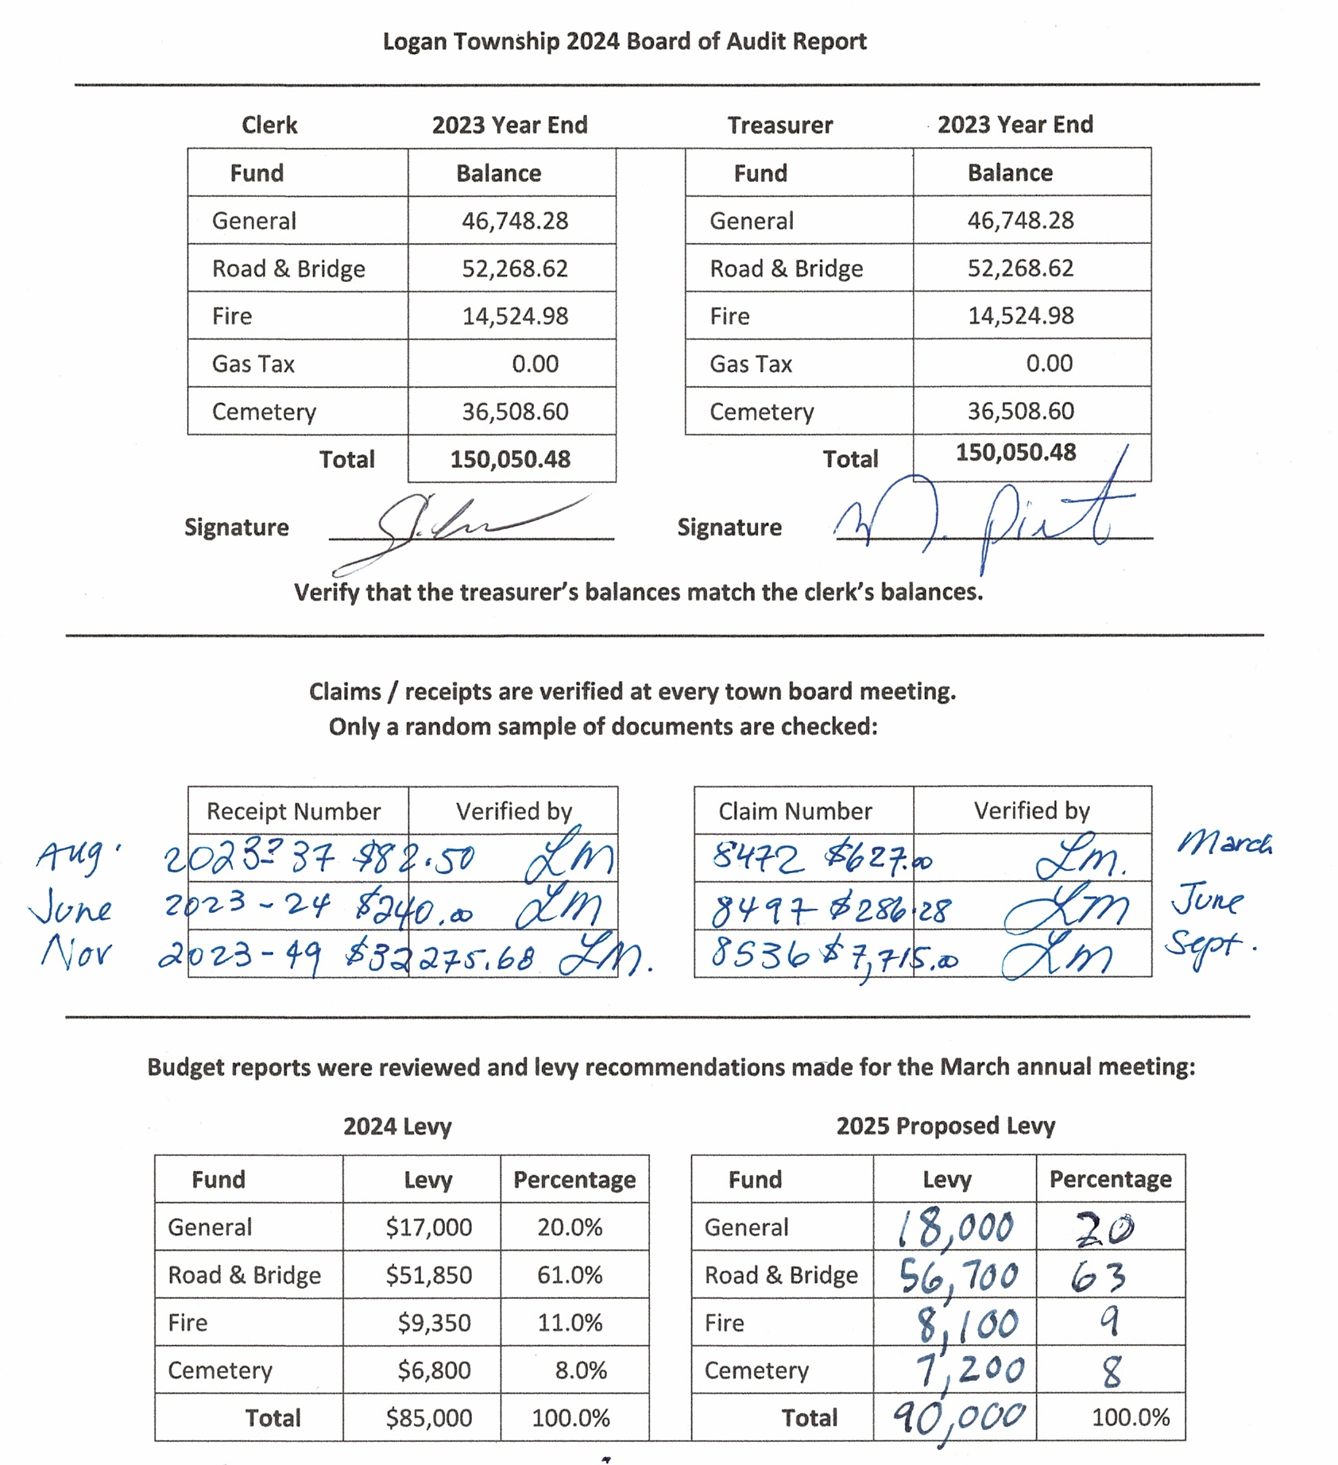

Logan Town Board Meeting Minutes
February 13, 2024
BOARD OF AUDIT AND PROPOSED LEVY:
- David Sims motioned to approve the 2024 Board of Audit report, second by Lisa Bryan. Motion passed with all in favor.
OLD BUSINESS:
- According to Minnesota Statute § 331A.03 Where Notice Published, a published notice shall be published in a qualified newspaper.
- PERA Exclusion Report and MATIT Worker’s Compensation Audit Reports were completed.
- Lynn Mizner attended the One Watershed One Plan January 2024 meeting.
ROAD REVIEW:
- 495th Lane does not have a 911 street sign because there are less than 3 residences on the road. Dave Sims will contact the highway department to see if there is a way to get a street sign.
- An invoice for $184.00 for salt/sand from 2023 that was used by Kern Excavating was received from the Aitkin County Highway Department.
NEW BUSINESS:
- The Presidential Nomination Primary is March 5. The clerk will pick up all election materials from Aitkin and return the required materials to the auditor after the polls have closed.
- August 13th is Primary Election Day. David Sims motioned to change the August 13th Town Board Meeting to August 15th, second by Lynn Mizner. Motion passed, all in favor.
- Aitkin County Planning and Zoning: 2018 to 2023 Permits and Variances received.
- Letter signed acknowledging requirement to obtain approval from Aitkin County Planning and Zoning for township projects that affect wetlands.
- ACAT Meeting January 2024: Lynn Mizner and Craig LeBlanc attended. A vote on MAT bylaws will take place at the spring short courses to meet the quorum of 10% of town officers.
- Minnesota Benefit Association: Basic Group Term Life Insurance will be purchased for the board.
- Barb Johnson was suggested as a potential Logan election judge by the Aitkin County Auditor.
CEMETERY:
- There are 81 names in the cemetery software database.
CORRESPONDENCE:
- Lakes and Pines: January 2024 Newsletter.
MOTION TO APPROVE CLAIMS:
- Dave Sims motioned to approve claims, second by Lisa Bryan. Motion passed, all in favor.
MOTION TO ADJOURN:
- Dave Sims motioned to adjourn at 8:50 pm, second by Lisa Bryan. Motion passed, all in favor.

____________________________________________ 3/12/2024
Dave Sims - Town Supervisor Date

