Logan Town Board Meeting Minutes
February 8, 2022
On February 8th, 2022 the Logan Town Board held their monthly meeting at the Palisade Community Center. Chair Dave Sims called the meeting to order at 7:15 pm.
Present: Chair Dave Sims, Supervisor Elissa Bryan, Supervisor Lynn Mizner,
Treasurer Lois Fultz and Clerk Craig LeBlanc.
- Lisa Bryan motioned to approve the January 2022 Logan Town Board Meeting minutes, second by Lynn Mizner. Motion passed, all in favor.
- Dave Sims motioned to approve the Treasurer’s Financial Statement with receipts of $8,387.42, disbursements of $4,607.49 and a total balance of $189,041.92, second by Lynn Mizner. Motion passed, all in favor.
- The Clerk’s books balance with the Treasurer’s books.
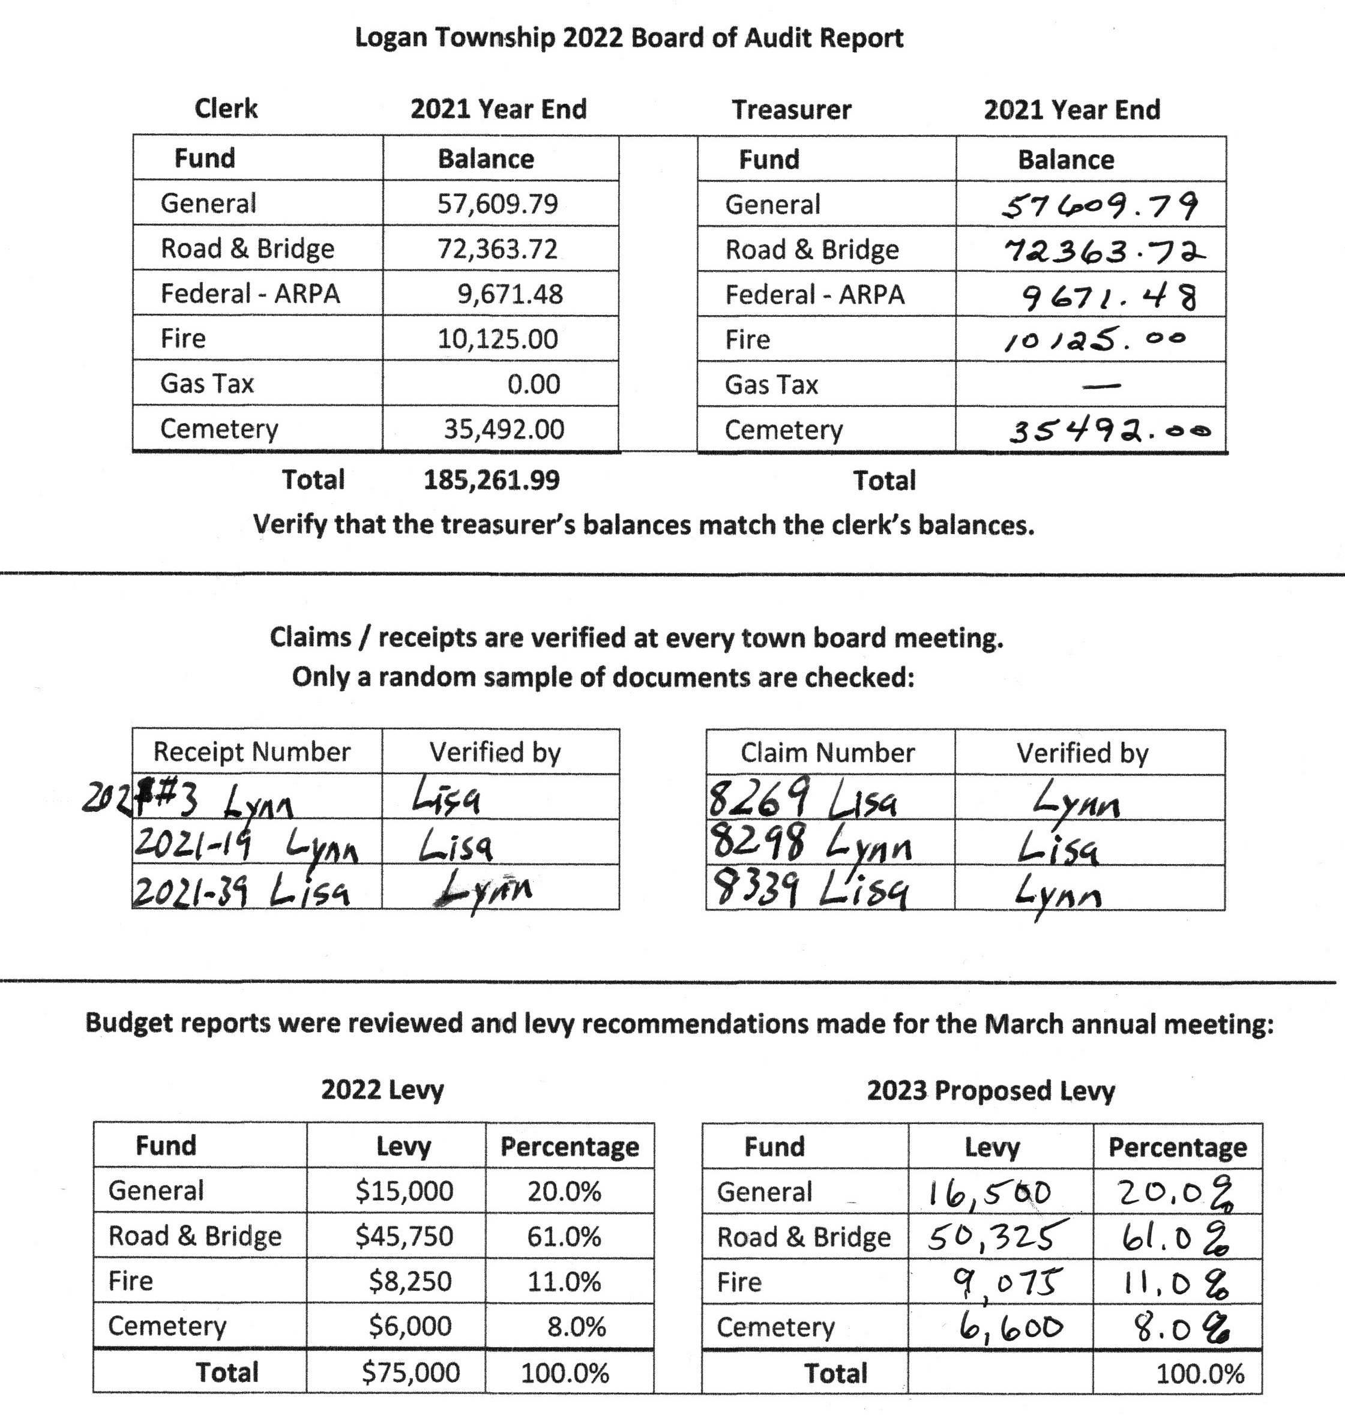
- Lynn Mizner motioned to review random checks and waive the reading of all checks, second by Dave Sims. Motion passed with all in favor.
- Lisa Bryan motioned to accept the books as true and correct, second by Lynn Mizner. Motion passed with all in favor.
- Dave Sims motioned to accept the 2023 levy proposal, second by Lisa Bryan. Motion passed with all in favor.
Logan Town Board Meeting Minutes
February 8, 2022
ROAD REVIEW:
- Certified copy of Aitkin County Resolution: Revert Portion of CSAH 3 to Logan Township.
This was adopted 10/8/2019 for the 290th Place extension to the relocated County Road 3.
- Lynn Mizner had Logan Township placed on the list for culvert location/inspection.
NEW BUSINESS:
- ACAT Meeting: January 20, 7:00 pm.
- MAT Legislative and Research Committee meeting is February 17th, 9 am to 3 pm.
CEMETERY:
- 2022 Cemetery Maintenance Contract pending.
CORRESPONDENCE:
- LTAP: Gravel Road Maintenance and Design Class - March 2022.
- Lakes and Pines Newsletter: January 2022.
- Central Applicators: Roadside Vegetation Management.
PUBLIC COMMENTS:

MOTION TO APPROVE CLAIMS:
- Dave Sims motioned to approve claims, second by Lynn Mizner Motion passed, all in favor.
MOTION TO ADJOURN:
- Lisa Bryan motioned to adjourn at 8:25 pm, second by Dave Sims. Motion passed, all in favor.

____________________________________________ Date 3/8/2022
Dave Sims - Town Supervisor

