Logan Town Board Meeting Minutes
February 9, 2021
On February 9th, 20210 the Logan Town Board held their monthly meeting at the Palisade Community Center. Chair Dave Sims called the meeting to order at 7:00 pm.
Present: Chair Dave Sims, Supervisor Elissa Bryan, Supervisor Lynn Mizner,
Treasurer Lois Fultz, Clerk Craig LeBlanc and Rod Kern.
- Lisa Bryan motioned to approve the January 2021 Logan Town Board Meeting minutes, second by Dave Sims. Motion passed, all in favor.
- Dave Sims motioned to approve the Treasurer’s Financial Statement with receipts of $11,270.33, disbursements of $4,599.81 and a total balance of $166,682.49, second by Lynn Mizner. Motion passed, all in favor.
- The Clerk’s books balance with the Treasurer’s books. 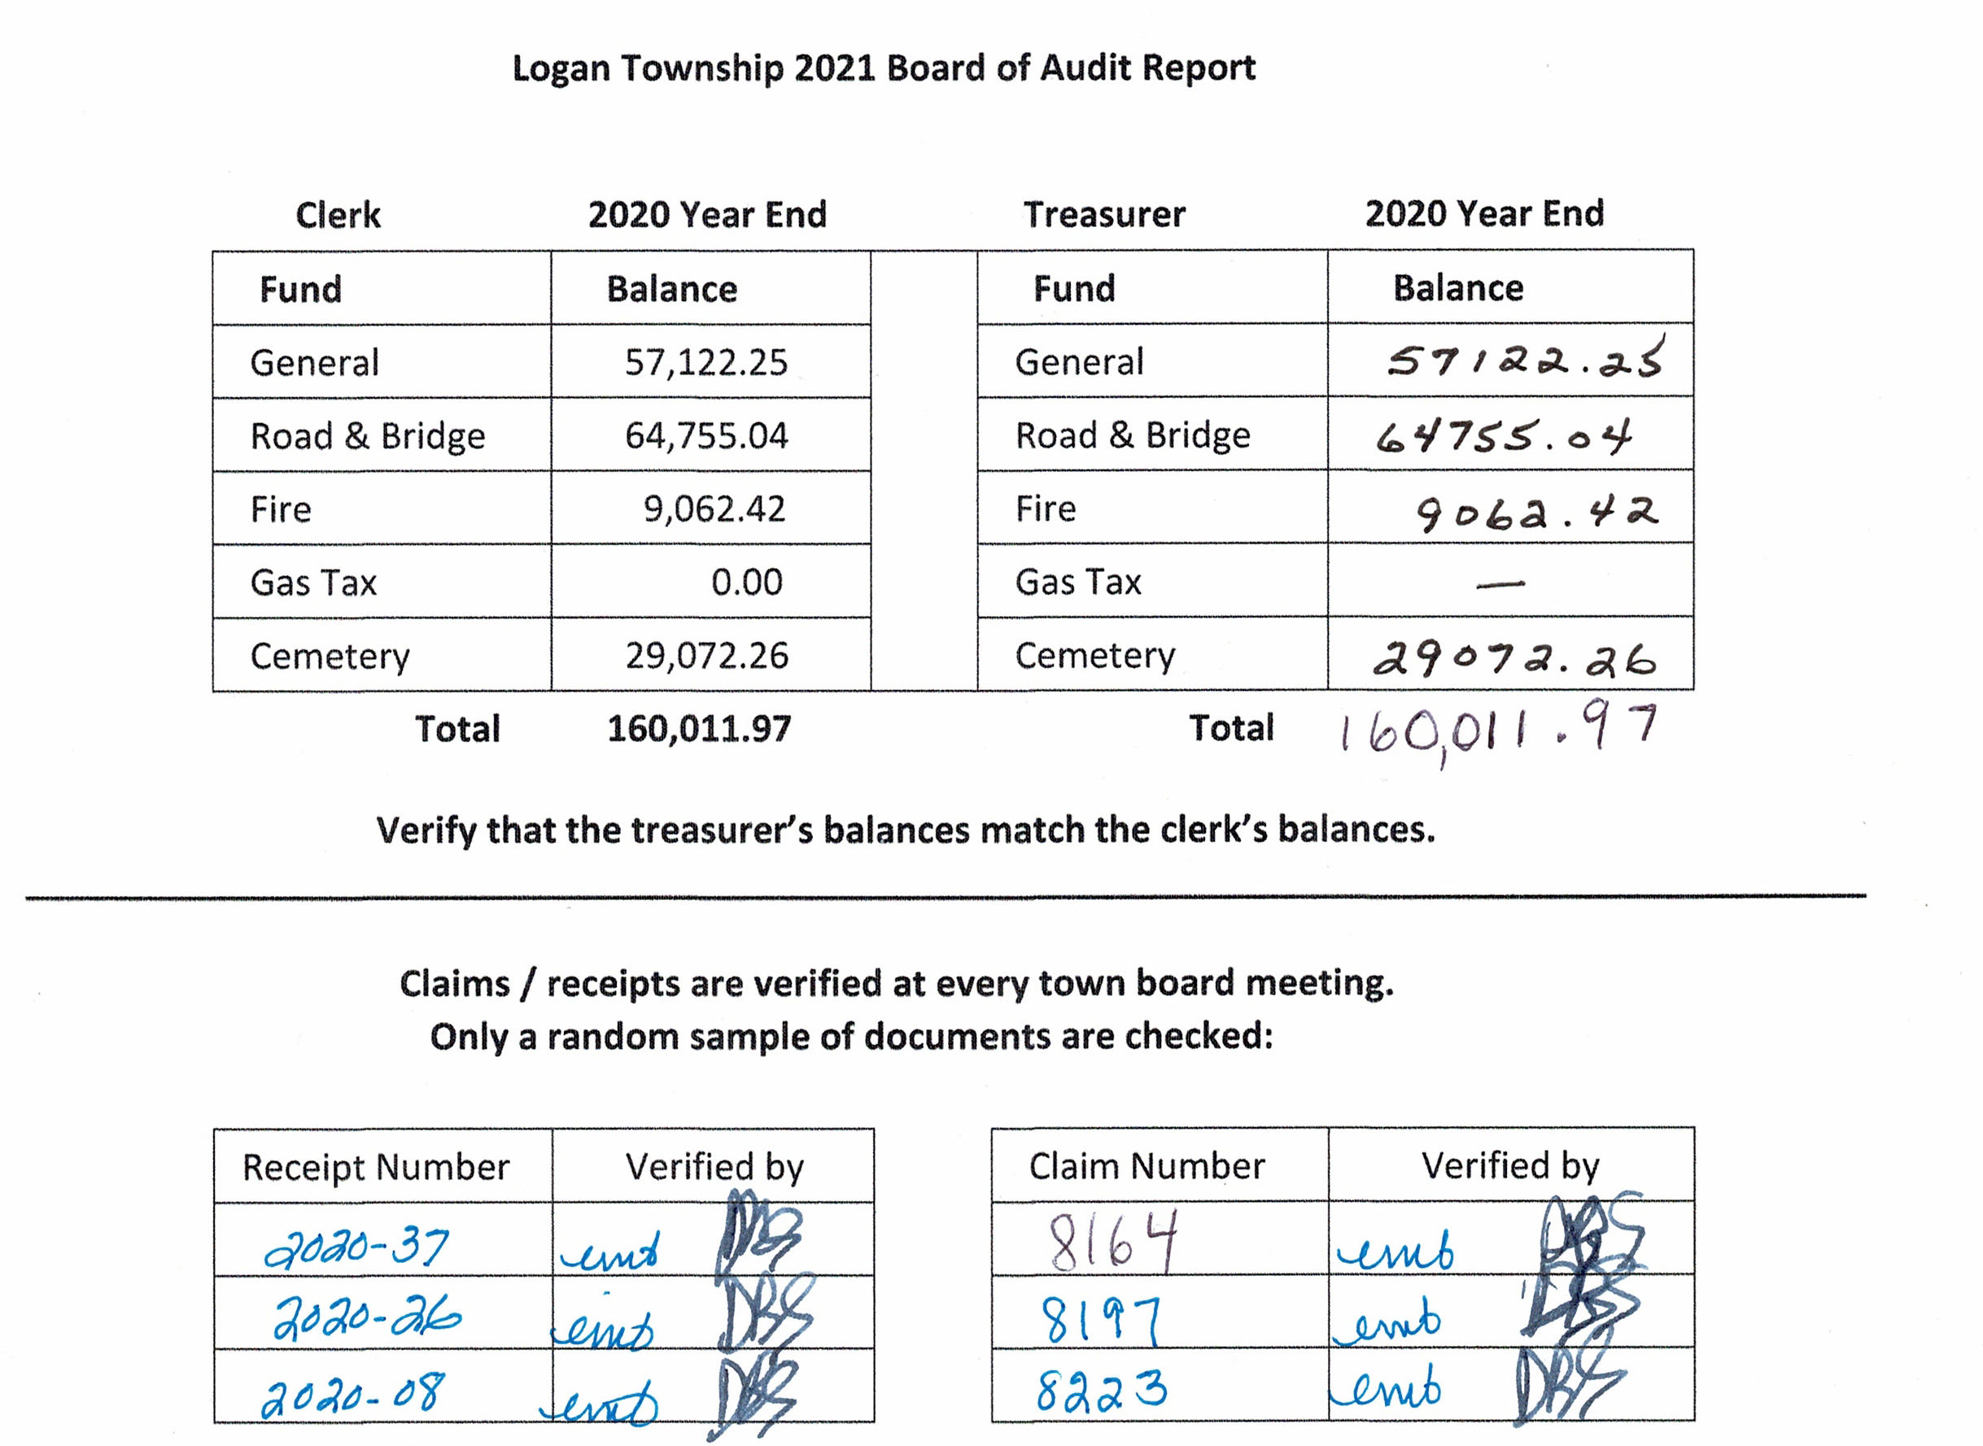

Dave Sims motioned to accept the books as true and correct, second by Lisa Bryan. Motion passed, all in favor.
all in favor.Fund | Levy Amount | Percentage |  | Fund | Levy Amount | Percentage
General | $16,500 | 22.0% |  | General | $15,000 | 20.0%
Road & Bridge | $44,250 | 59.0% |  | Road & Bridge | $45,750 | 61.0%
Fire | $7,500 | 10.0% |  | Fire | $8,250 | 11.0%
Cemetery | $6,750 | 9.0% |  | Cemetery | $6,000 | 8.0%
Total | $75,000 | 100.0% |  | Total | $75,000 | 100.0%
2021 Levy 2022 Proposed Levy
The Road & Bridge levy percentage was increased to cover a planned increase in road repairs. The Fire levy percentage was increased to cover an expected increase in the Fire Protection cost. Lisa Bryan motioned to accept the 2022 levy proposal, second by Dave Sims. Motioned passed with all in favor.

Logan Town Board Meeting Minutes
February 9, 2021

OLD BUSINESS:
- Lynn Mizner is on the new signature card at Security State Bank. The other town officers need to stop in
to update the card.
ROAD REVIEW:
- The board reviewed the preliminary 2021 Annual Road Report listing the levy, receipts, expenses, maintenance,
materials, and completed/uncompleted improvements for 2020. The board added 2021 road improvements and more extensive repairs to increase the durability of roads and decrease long-term maintenance costs. This report will be presented at the annual meeting as required by Minnesota Statute §164.03 Expenditures for Roads.
NEW BUSINESS:
- ACAT February 2021 Newsletter and review/revision of ACAT by-laws.
- Lynn Mizner attended the MPCA public hearing on changes to water quality standards. The proposed standards would change from numerical/narrative standards to narrative only standards that could weaken limits for chlorides (salt), calcium (hardness) and pH (acidity) that affect fish, aquatic life and water quality.
- The board approved basic Group Term Life Insurance from the Minnesota Benefit Association.
- MAT Legislative and Research Committee meeting is February 17. Clerk Craig LeBlanc plans to attend.
- The City of Palisade will be reimbursed $75 for Community Center use in January, February and March 2020.
- The board will work on a policy for meeting reimbursement.
CEMETERY:
- 2021 Cemetery Maintenance contract was signed.
CORRESPONDENCE:
- Enbridge: Line 3 Open House was January 28th, 2021.
- Lakes and Pines: January 2021 Newsletter.

PUBLIC COMMENTS:

MOTION TO APPROVE CLAIMS:
- Lisa Bryan motioned to approve the claims, second by Lynn Mizner. Motion passed, all in favor.
MOTION TO ADJOURN:
- Dave Sims motioned to adjourn the meeting at 8:20 pm, second by Lisa Bryan. Motion passed, all in favor.

