Logan Town Board Meeting
Record of Proceedings
February 12, 2020
On February 12, 2020 the Logan Town Board held their monthly meeting at the Palisade Community Center. Chair Dave Tevis called the meeting to order at 7:00 pm.
Present: Chair Dave Tevis, Supervisor Elissa Bryan, Treasurer Lois Fultz,
Clerk Craig LeBlanc and Rod Kern.
- Dave Tevis motioned to approve the January 2020 minutes, second by Lisa Bryan. Motion passed with all in favor.
- Lisa Bryan motioned to approve the Treasurer’s Financial Statement with receipts of $9,396.63, disbursements of $3,322.01 and a total balance of $135,885.70, second by Dave Tevis. Motion passed with all in favor.
- The Clerk’s books balance with the Treasurer’s books.
2020 BOARD OF AUDIT
- The 2019 Board of Audit minutes were reviewed.
- Treasurer Lois Fultz read the 2019 Year End Statement with total assets of $129,811.08 in checking, savings, and CD’s.
- Dave Tevis motioned to review random receipts/disbursements and waive the review of all transactions, second by Lisa Bryan. Motion passed with all in favor.
- The Board audited the Clerk’s books, Treasurer’s books and bank statements with a check of randomly chosen receipts and disbursements. Dave Tevis motioned to accept the books as true and correct, second by Lisa Bryan. Motion passed with all in favor.
- The board proposed an overall levy increase to $75,0000 and redistribution of the fund percentages to cover pending road improvements.
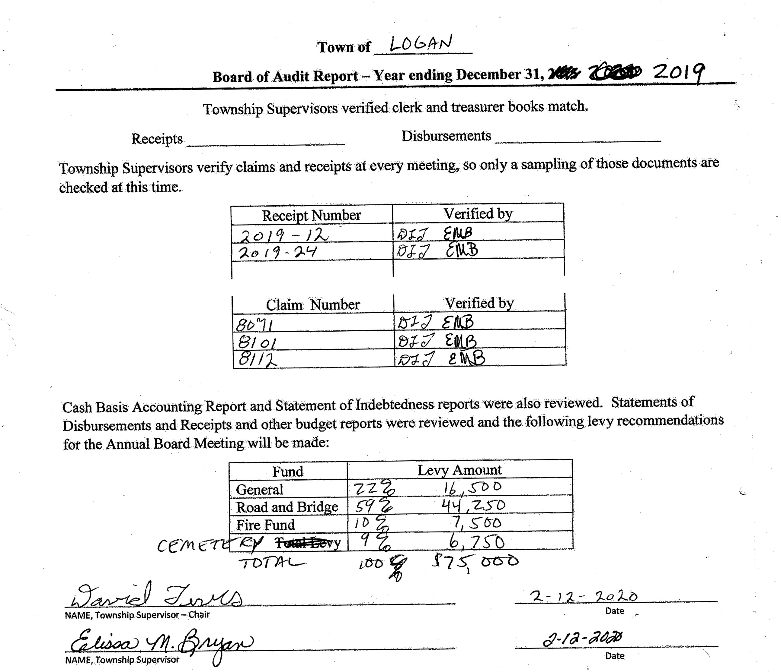
Logan Town Board Meeting
Record of Proceedings
February 12, 2020

OLD BUSINESS:
- City of Palisade Wellhead Protection Plan: Request for comments from Local Government Units
ROAD REVIEW:
- Certificate of Insurance was received from Dale Hansen.
NEW BUSINESS:
- Dave Tevis motioned to change the town board meetings to the second Tuesday of the month, second by Lisa Bryan. Motion passed with all in favor.
- January ACAT meeting:
Presentation on the 2020 Census and request for census workers.
There are 42 mail-in precincts in Aitkin County.
There will be an ACAT rule review at the April 22nd meeting.
- Minnesota Benefit Association Group Life Insurance will be purchased for the town board.
- The Presidential Nomination Primary is March 3rd, 2020.
CEMETERY:
- The maintenance contract will be discussed with the City of Palisade in April.
CORRESPONDENCE:
- Couri & Ruppe: Township Legal Seminar - February 15th, 2020 Glen Kimberly Town Hall.
- Lakes and Pines: January 2020 Newsletter.
- Minnesota LTAP: Gravel Roads Design and Maintenance Workshop - April 2020.
- Road Groom Manufacturing: Road Grading Equipment.
MOTION TO APPROVE CLAIMS:
- Lisa Bryan motioned to approve the claims, second by Dave Tevis. Motion passed, all in favor.
MOTION TO ADJOURN:
- Lisa Bryan motioned to adjourn at 8:00 pm, second by Dave Tevis. Motion passed with all in favor.

